**Analysis Document**

***eSB PeopleSoft Team***

**PS TWS Calendar Automation**

*[Note: Text displayed in blue italics is included to provide guidance to the author and should be selected and right mouse clicked. Choose Font from the Pop-up menu and under Effects checked hidden before publishing the document.]*

|  |  |
| --- | --- |
| Document Version: | 1.0 |
| Document Date: | 08/18/2015 |

Revision History Page

| Date | Version | Description | Author |
| --- | --- | --- | --- |
| 08/18/2015 | 1.0 | Initial Creation | Sheena Marie Suzzane Catacutan |

|  |  |  |  |
| --- | --- | --- | --- |
| Access Control List | | | |
|  |  |  |  |
| **List of Users** | **Access Type** | | **Involvement** |
| **Read** | **Write** |
| PeopleSoft Release Developer | X | X | Implementer |
| PeopleSoft Reviewer | X | X | Affected |
| PeopleSoft Lead | X |  | Affected |
| PeopleSoft Developers | X |  | Affected |

**TABLE OF CONTENTS**

Tool Description 1

Existing Scenario Addressed 1

Benefits 1

Business Flow 1

Disadvantages 2

Limitations 2

Issues 2

Sign-Off 2

Appendix 2

Definition of Terms

* Calendar day – any day of the week, including weekends. It relates to any day of the week, month or year. It contrasts the weekday, which usually means any day of the week except the weekend days, which in most parts of the world are Saturday, Sunday or both.
* Business day – considered every official working day of the week. Another common term is **working day**. Typically, these are the days between and including Monday to Friday and do not include public holidays and weekends.
* Holiday - a day marked by a general suspension of work in commemoration of an event

Tool Description

PeopleSoft has a lot of jobs that are predetermined to run on a specific day based on the TWS Calendars. Automated PS TWS Calendar will be engineered to provide calendars for the current TWS jobs of PeopleSoft.

Input will be

* Calendar Name
* Holiday List (Banking and UHC holiday)
* Calendar Year

Output will be

* Excel Spreadsheet with all the run days and holidays (differentiate between Banking and UHC Holiday, there may be times these are on the same day).
* Text file version of all the runtimes per calendar as this will be used as input in TWS.

This tool utilizes Java 1.7, jQuery, Spring MVC, Apache POI and Apache Tomcat 8.

Job Calendars in-scope

|  |  |  |
| --- | --- | --- |
| Autosys Calendar Name | TWS Calendar name | Calendar is scheduled on: |
| PSF_BIL_CL_1ST_WD_WK | PSFBIL05 | This calendar runs during Workday 4 |
| PSF_ACR_CL_WD1_CHK | PSFACR15 | Runs the day after workday 1 |
| PSF_BIL_CL_WKD_TO_SAT_SKIP_MON | PSFBIL02 | Runs every workday plus 2nd and 3rd Saturdays of the month. However it does not on corporate holidays. |
| PSF_ACR_CL_BI_PIA_UNRD_CAL_18 | PSFACR14 | Runs on calendar Day 18 - if the 18th falls on a Saturday, then it runs on the 17th. If the 18th falls on a Sunday, then it runs on the 19th. |
| PSF_BIL_CL_NON_1ST_WD_WK | PSFBIL03 | Runs every work day except workday 1 and workday 4 . It does not run on holidays. |
| PSF_ACR_CL_RR_ESBPP_LS | PSFACR12 | This calendar is scheduled to run on eSBPP Rollback Reconvert dates. |
| PSF_BIL_CL_CTS_WKLY | PSFBIL01 | This calendar is for the weekly processing of the CTS feed file. |
| PSF_ACR_CL_ADHOC_LOCKBOX | PSFACR08 | Calendar is use to process lockbox files when banks are open but UHG is closed. It runs the Saturday after Thanksgiving and also may run if any other UHC Holidays fall on a banking day. |
| PSF_ACR_CL_BI_NON_WD1_CHK | PSFACR13 | Run the day after the PSF_ACR_CL_BI_NON_WD1 (even if it is weekend or holiday) |
| PSF_ACR_CL_WEEKDAYS | PSFACR16 | Runs every weekdays except holidays, workday 1, last work day and the days that PSFACR11 runs |
| PSF_ACR_CL_DAILY | PSFACR17 | Runs every weekdays except on holidays, workday 1, workday 5 and the days that PSF_ACR_CL_CAL_DAY18 runs |
| PSF_ACR_CL_2PRI_CAL1 | PSFACR00 | This is for scheduled direct debit jobs for Medica group. The jobs will run 2 business days prior to settlement date of calendar day 1. If calendar day 1 is a holiday or weekend, the next business day is treated as calendar day 1. The jobs will not run on WD 1. |
| PSF_ACR_CL_2PRI_CAL24 | PSFACR02 | This is for scheduled direct debit jobs for the 24th of the month scheduled direct debit group. This jobs under this calendar runs 2 business days prior to settlement date of calendar day 24. If calendar day 24 is a holiday or weekend, the next business day is treated as calendar day 24. |
| PSF_ACR_CL_2PRI_CAL25 | PSFACR03 | This is for scheduled direct debit jobs for the 25th of the month scheduled direct debit group. This jobs under this calendar runs 2 business days prior to settlement date of calendar day 25. If calendar day 25 is a holiday or weekend, the next business day is treated as calendar day 25. |
| PSF_ACR_CL_2PRI_CAL6 | PSFACR04 | This is for scheduled direct debit jobs for the 6th of the month scheduled direct debit group. This jobs under this calendar runs 2 business days prior to settlement date of calendar day 6. If calendar day 6 is a holiday or weekend, the next business day is treated as calendar day 6. |
| PSF_ACR_CL_4PRI_CAL1 | PSFACR06 | This is for scheduled direct debit jobs for Medica group. The jobs will run 4 business days prior to settlement date which is calendar day 1. If calendar day 1 is a holiday or weekend, the next business day is treated as calendar day 1. This is used if there are more than 2 days from the run date and the settlement date (i.e. weekends, holidays, etc).The jobs will not run on WD 1. |
| PSF_ACR_CL_2PRI_CAL10 | PSFACR01 | This is for scheduled direct debit jobs for the 10th of the month scheduled direct group. This jobs under this calendar runs 2 bus days prior to settlement date of calendar day 10. If calendar day 10 is a holiday or weekend, the next business day is treated as calendar day 10. |
| PSF_ACR_CL_AR032UHC_10 | PSFACR10 | Runs 2 business days prior to the day that PSFACR01 runs |
| PSF_ACR_CL_AR032UHC_01 | PSFACR09 | Runs 2 business days prior to the day the PSFACR00 and PSFACR06 runs |
| PSF_ACR_CL_AUTO_MAINT_ZERO_BAL | PSFACR11 | The jobs on this calendar will run on Fridays and Last workday of the month excluding Holidays. It also runs on every day that AR_2PRI_CAL10 is scheduled. This calendar should not be scheduled to run on WD1. |
| PSF_ACR_CL_2PRI_NON_WD1_BYPASS | PSFACR05 | Runs all weekdays other than: Holidays, workday 1 and the days that the following calendars run: PSFACR00, PSFACR01, PSFACR02 PSFACR04 , PSFACR06, PSFACR03 |

Example input:

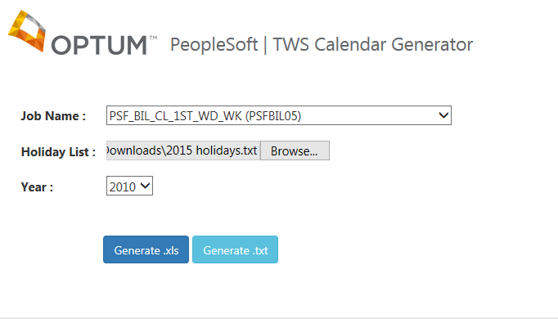

Example output:

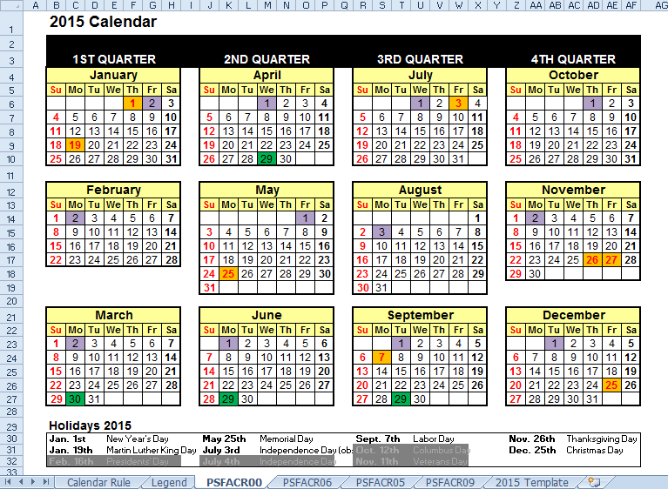

# Existing Scenario Addressed

* Dependency on the manual marking of multiple job calendars.
* Time consuming.
* Manual marking is error prone.
* Missing a job schedule causes huge issues that impact the business.

# Benefits

* Generate job calendars on-the-go
* Accurate job schedules are marked in the calendar

# Business Flow

N/A

## Disadvantages

* None identified

## Limitations

The tool only limits to TWS job calendars specified above (Job Calendars in-scope). Other shared calendars used by PeopleSoft are excluded in the tool.

# Issues

*Detail any outstanding issues that need be resolved before the Detailed Design can be completed.*

| No. | Issue Date | Issue Description | Assigned Resource | Issue Resolution |
| --- | --- | --- | --- | --- |
|  |  | None identified |  |  |

# Sign-Off

Signature indicates understanding and acceptance of the content contained within this document.

|  |  |  |
| --- | --- | --- |
| Sheena Marie Suzzane Catacutan |  | 08/18/2015 |
| Document Owner |  | Date |
|  |  |  |
|  |  |  |
| Reviewer 1 (Position to be filled in by each Release) |  | Date |
|  |  |  |
|  |  |  |
| Reviewer 2 (Position to be filled in by each Release) |  | Date |

# Appendix

1. Screenshots
2. Related Documents

#### GUIDELINES – When to create an Analysis Document:

An Analysis Document should be completed if at least one of the following is met:

1. If there is a functional error but no functional design specifications exist
2. If there is a technical error and at least one of the following is impacted:
   1. Performance
   2. Database design
   3. Input/output layout
   4. Framework (e.g. business event flow)
   5. If the fix requires a new component